Generating Banzai APK in Eclipse

Unzip and open eclipse (zip file located in /Documents/Eclipse.zip) and import the Banzai project (located in /Code/Banzai-Android/Banzai in the repo)

1. Right click on the project
2. Mouse over “**Android Tools**”
3. 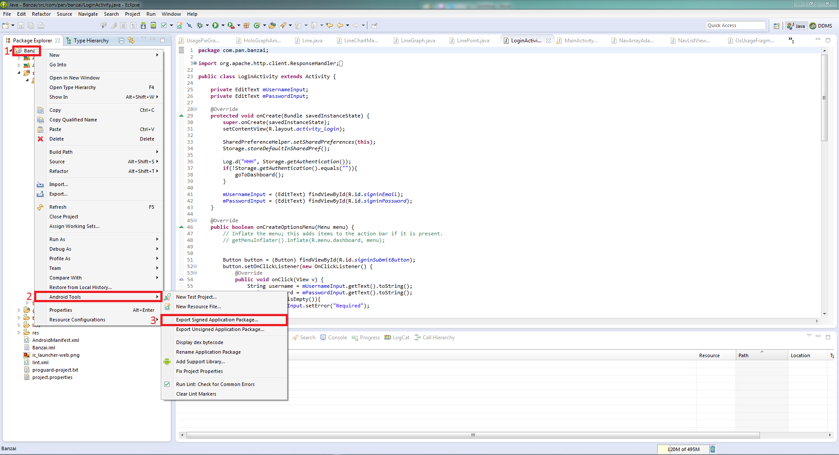Click on “**Export Signed Application Package…**”
4. 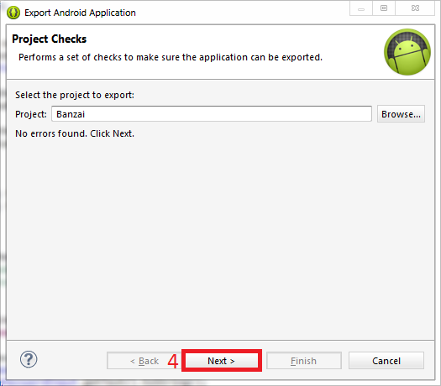A new window will open up. Click “**Next**”
5. In the “**Location**” box, search for the keystore for the project. It is located at **/Code/Banzai-Android/banzai-keystore.jdk**
6. Enter “**banzai**” as the password
7. 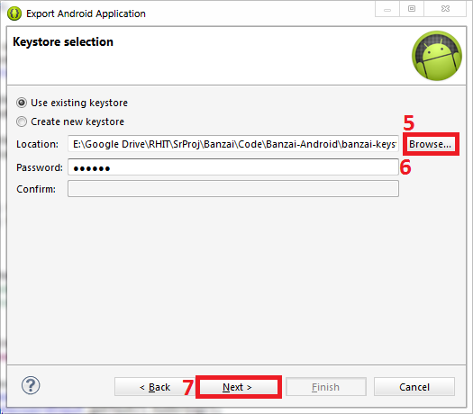Click “**Next**”
8. Make sure “**Use existing key**” is checked and the “**banzaikey**” alias is selected. Then enter “**banzai**” as the password.
9. 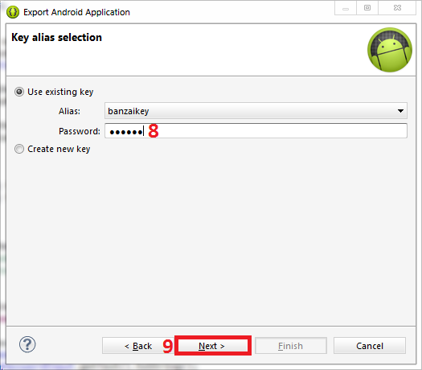Click “**Next**”
10. Browse for your desired export location
11. 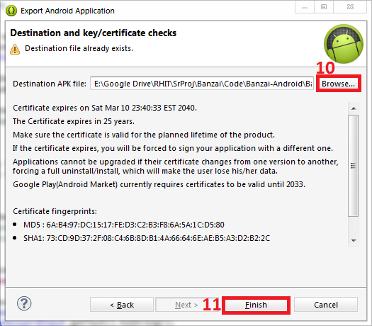Click “**Finish**” and you’re done.

**Troubleshooting:**

Sometimes eclipse will throw errors when trying to export. 2 ways to fix this is to clean the project (Right click the project > clean) or just close/open eclipse again.